# EE655 Modem Design Homework Assignment #2

## Task 1)

### a)





theta_0=2*pi/25;

clear

close all

theta_0=1/25;

eta = sqrt(2)/2;

eta=1.0*eta;

denom = (1+2*eta*theta_0+theta_0*theta_0)

k_i = (4*theta_0*theta_0)/denom;

k_p = (4*eta*theta_0)/denom;

dphi=[0.05*ones(1,200) 0.10*ones(1,200)];

phi_1=filter(1,[1 -1],dphi);

s_1 = exp(j*2*pi*phi_1);

phi_sv = zeros(1,400);

int_sv = zeros(1,400);

accum_sv = zeros(1,400);

dphi_sv = zeros(1,400);

phi_2_sv= zeros(1,400);

int = 0;

accum = 0;

for nn=1:400

% Multiplier

prod = s_1(nn)*exp(-j*2*pi*accum);

phi = angle(prod)/(2*pi);

phi_sv(nn) = phi;

% Loop filter

int = int + k_i*phi;

dphi = k_p*phi+int;

dphi_sv(nn) = dphi;

% DSS

phi_2_sv(nn) = accum;

accum = accum+dphi;

end

figure

subplot(2,1,1)

plot(0:length(phi_sv)-1,phi_sv)

title('Loop phase error')

subplot(2,1,2)

plot(dphi_sv);

grid on;

title('Output of Loop Filter, DDS Control Frequency')

figure

plot(0:length(phi_1)-1,phi_1)

hold on

plot(0:length(phi_2_sv)-1,phi_2_sv, 'r')

title('Input and output phase')

legend('Input Phase','Output Phase')

ylim([0 max(phi_1)])

figure

subplot(2,1,1)

plot(0:length(s_1)-1,real(s_1))

hold on

plot(0:length(phi_2_sv)-1,cos(2*pi*phi_2_sv))

title('Real Part of input/output signals')

legend('Input', 'Output')

subplot(2,1,2)

plot(0:length(s_1)-1,imag(s_1))

hold on

plot(0:length(phi_2_sv)-1,sin(2*pi*phi_2_sv))

title('Imaginary Part of input/output signals')

legend('Input', 'Output')

## Task 2)

### a)

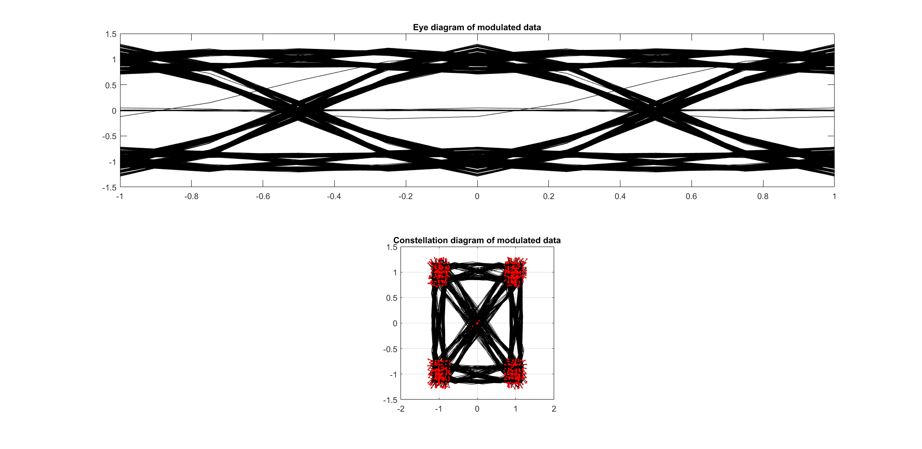

For plotting constellations and eye diagrams, two functions were created, ***plotEyeDiagram()*** and ***plotConstellationDiagram()***. These are used henceforth to create those diagrams. The code can be found below.

function [null] = plotEyeDiagram(x1,fs,str)

%Plots the constellation diagram of a modulated signal

% x1 = modulated signal

% fs = samples per symbol of x1

% str = title of plot

plot(0,0)

hold on

for n=1:fs:fs*1000-fs*2

plot(-1:1/fs:1, real(x1(n:n+fs*2)), 'k')

end

hold off

title(str)

end

function [null] = plotConstellationDiagram(x1,fs,str)

% Plots the constellation diagram of a modulated signal

% x1 = input data

% fs = samples per symbol of x1

% str = title of plot

plot(x1, 'k')

grid on

axis('square')

hold on

plot(x1(1:fs:length(x1)),'r.')

title(str)

end

And the script to solve the problem follows:

clear

close all

%task A

N = 1000

sigma = 0.02

fs = 4

h = rcosine(1, fs, 'sqrt', 0.5, 6);

h = h/max(h);

x0 = ((floor(2*rand(1,N))-0.5)/0.5)+j*((floor(2*rand(1,N))-0.5)/0.5);

x1 = zeros(1, 4*N);

x1(1:4:4*N) = x0;

x1 = filter(h,1,x1);

subplot(2,1,1)

plotEyeDiagram(x1,fs,'Eye diagram of modulated data')

subplot(2,1,2)

plotConstellationDiagram(x1,fs,'Constellation diagram of modulated data')

### b)

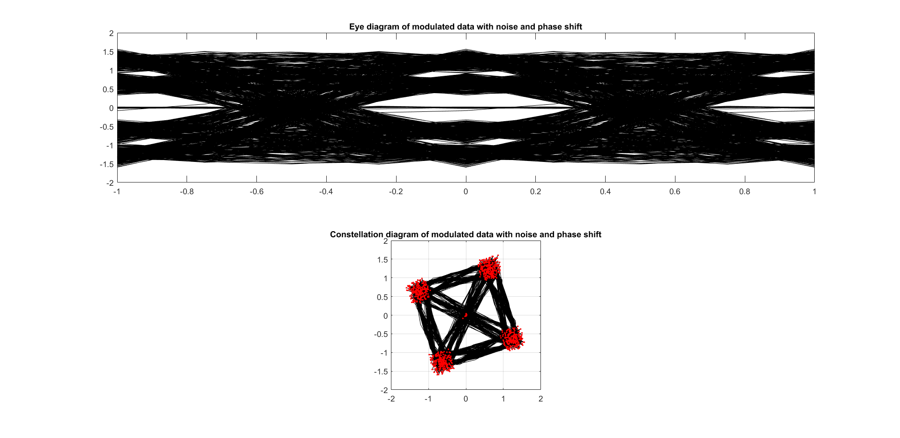

figure

x2 = x1 + sigma*(randn(1,length(x1))+j*randn(1,length(x1)));

x3 = x2 * exp(j *2*pi*0.05);

subplot(2,1,1)

plotEyeDiagram(x3,fs,'Eye diagram of modulated data with noise and phase shift')

subplot(2,1,2)

plotConstellationDiagram(x3,fs,'Constellation diagram of modulated data with noise and phase shift')

### c)

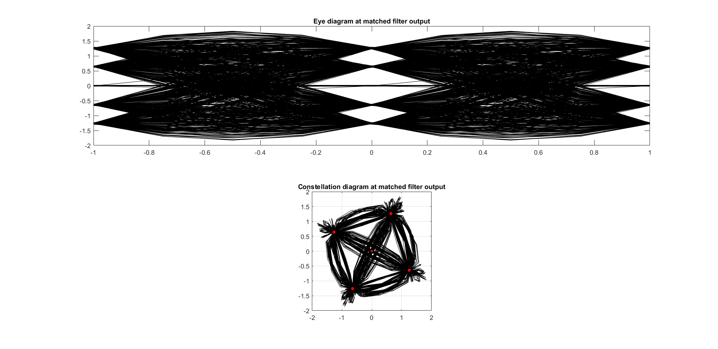

hm = h/(h*h');

y=filter(hm,1,x3);

figure

subplot(2,1,1)

plotEyeDiagram(y,fs,'Eye diagram at matched filter output')

subplot(2,1,2)

plotConstellationDiagram(y,fs,'Constellation diagram at matched filter output')

### d)



x5 = zeros(1,fs*N);

reg = zeros(1,49);

for n=1:fs*N

reg=[x3(n) reg(1:48)];

x5(n)=reg*hm';

if n>20

if rem(n,4)==1;

x5_d=sign(real(x5(n)));

y5_d=sign(imag(x5(n)));

i = (n-1)/4;

p2(i) = (x5_d+j*y5_d)*conj(x5(n));

hold on

end

end

end

figure

subplot(2,1,1)

plot(p2(20:end), 'k')

grid on

axis('square')

hold on

plot(p2(20:end),'r.')

title('Output of detector')

subplot(2,1,2)

plot(0:length(p2)-1, angle(p2)/(2*pi))

title('Output of ATAN')

### e)

theta_0= 2*pi/1000;

eta=sqrt(2)/2;

eta=1*eta;

k_i= (4*theta_0*theta_0)/(1+2*eta*theta_0+theta_0*theta_0);

k_p= (4*eta*theta_0)/(1+2*eta*theta_0+theta_0*theta_0);

phs_accum=0;

int=0;

fltr_hld=0;

reg=zeros(1,49);

m=1;

p2_sv = zeros(1,999)

d_phi_sv = zeros(1,999);

for n=1:4000

p1=x3(n)*exp(-j*2*pi*phs_accum);

reg=[p1 reg(1:48)];

x5(n)=reg*hm';

if n>20

if rem(n,4)==1;

x5_d=sign(real(x5(n)));

y5_d=sign(imag(x5(n)));

i = (n-1)/4;

p2 = (x5_d+j*y5_d)*conj(x5(n));

p2_sv(i) = p2;

d_phi=-angle(p2)/(2*pi);

d_phi_sv(m)=d_phi;

int=int+d_phi*k_i;

fltr=int+d_phi*k_p;

fltr_hld=fltr;

m=m+1;

end

phs_accum_sv(n)=phs_accum;

phs_accum=phs_accum+fltr_hld;

end

end

### f)



figure

subplot(3,1,1)

plotConstellationDiagram(x5(1001:end),fs,'Constellation diagram with PLL)')

subplot(3,1,2)

plot(p2_sv(20:end), 'k')

grid on

axis('square')

hold on

plot(p2_sv(20:end),'r.')

title('Output of detector')

subplot(3,1,3)

plot(0:length(p2_sv)-1, angle(p2_sv)/(2*pi))

title('Output of ATAN')